NETWORKING TASK 01 – UNDERSTANDING YOUR NETWORK ENVIRONMENT
Name: ______________________
Date: ______________________
Objective
The objective of this task is to understand the basic components of a computer network and identify the network configuration of a system.

Part A: Network Information
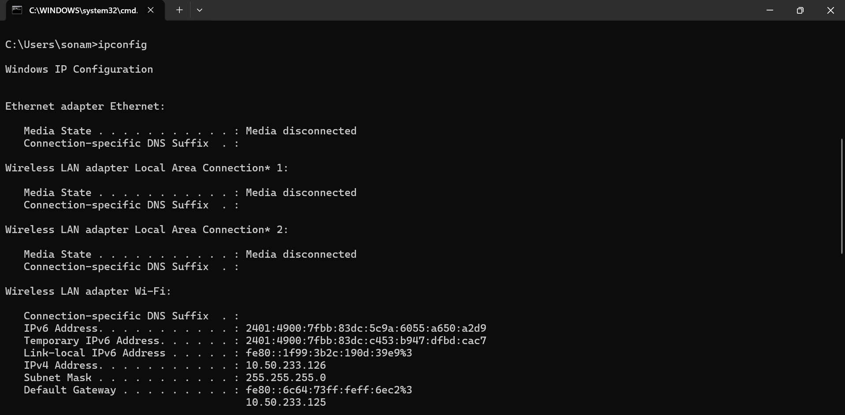

Part B: Basic Networking Concepts
1. What is an IP Address?
An IP (Internet Protocol) Address is a unique numerical identifier assigned to a device connected to a network. It enables devices to communicate with each other over the internet or a local network.
2. What is a MAC Address?
A MAC (Media Access Control) Address is a unique hardware address assigned to a network interface card (NIC) by the manufacturer. It helps identify devices within a local network.
3. What is a Default Gateway?
A Default Gateway is a networking device, usually a router, that forwards data from a local network to external networks such as the internet.
4. What is DNS?
DNS (Domain Name System) is a service that translates human-readable domain names such as google.com into IP addresses that computers can understand.
5. Difference Between Public IP and Private IP
Public IP Address | Private IP Address
Used on the internet | Used within local networks
Assigned by Internet Service Provider (ISP) | Assigned by router or administrator
Globally unique | Can be reused in different networks
Accessible from the internet | Not directly accessible from the internet

Part C: Basic Network Diagram
The following diagram shows how a device connects to the internet:
Internet
│
▼
Router / Wi-Fi
│
▼
Your Device
Network Diagram
[Insert Draw.io / Canva / PowerPoint / Hand-drawn Diagram Screenshot Here]

Part D: Network Connectivity Test
Commands Executed
1. ipconfig
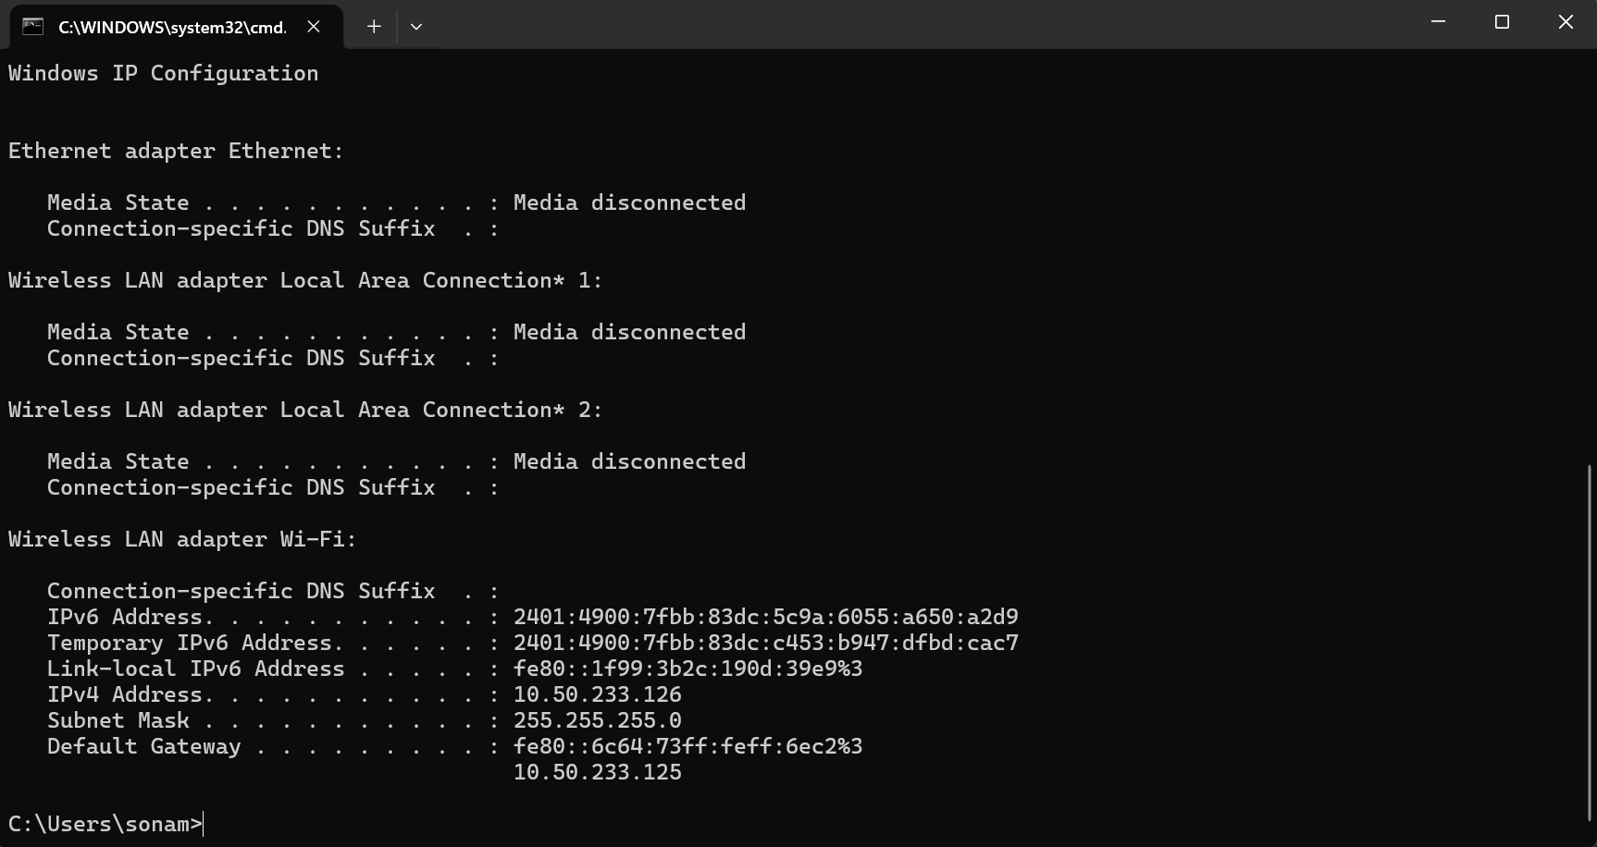
2. ping google.com
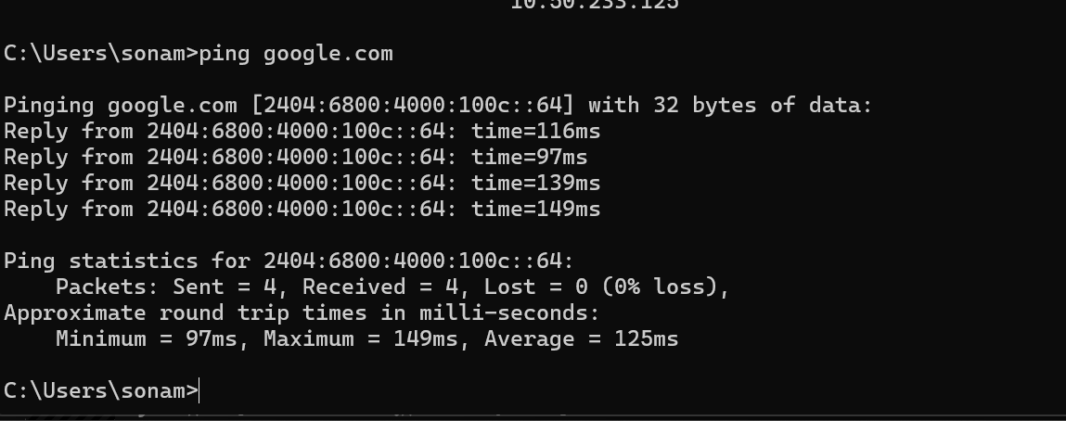

3. tracert google.com
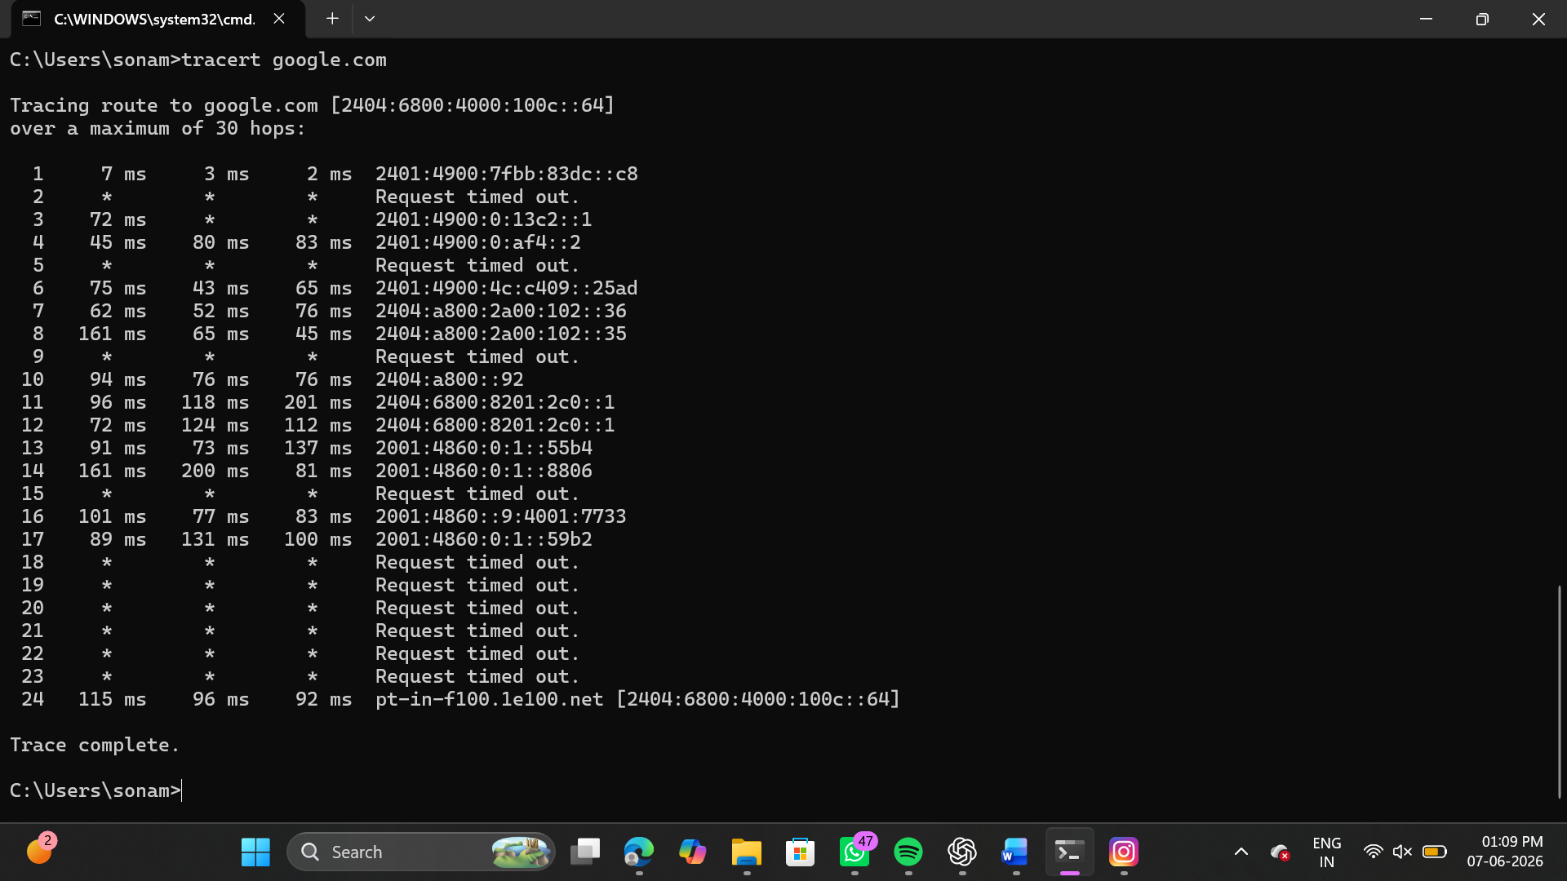

Questions and Answers
1. Was the ping successful?
Answer:
Yes, the ping was successful. The system received replies from google.com, indicating that the internet connection was working properly.
2. How many hops were shown?
Answer:
Tracing route to google.com [2404:6800:4009:80b::200e]
over a maximum of 30 hops:
1 3 ms 3 ms 2 ms 2401:4900:7fbb:83dc::c8
2 * * * Request timed out.
3 * * 63 ms 2401:4900:0:13c1::1
4 56 ms 64 ms 46 ms 2401:4900:0:af4::2
5 * * * Request timed out.
6 61 ms 72 ms 79 ms 2401:4900:4c:c409::25ad
7 49 ms 55 ms 40 ms 2404:a800:2a00:102::3a
8 73 ms 59 ms 86 ms 2404:a800:2a00:102::39
9 * * * Request timed out.
10 109 ms 85 ms 70 ms 2404:a800::92
11 97 ms 79 ms 223 ms 2404:6800:8201:180::1
12 98 ms 78 ms 74 ms 2404:6800:8201:180::1
13 80 ms 87 ms 92 ms 2001:4860:0:1::55fe
14 103 ms 79 ms 86 ms 2001:4860:0:1::17d6
15 * * * Request timed out.
16 139 ms 86 ms 198 ms 2001:4860::9:4002:d931
17 93 ms 77 ms 75 ms 2001:4860:0:1::3fe5
18 92 ms 156 ms 220 ms 2001:4860:0:1::269d
19 81 ms 76 ms 74 ms bom07s16-in-x0e.1e100.net [2404:6800:4009:80b::200e]
Trace complete.
3. What is the purpose of traceroute?
Answer:
Traceroute is a network diagnostic tool used to trace the path taken by data packets from a source device to a destination server. It helps identify network delays, routing paths, and connectivity issues.

README Summary
Task Summary
This networking task helped in understanding the basic concepts of computer networks and network configuration.
Activities Performed
- Identified Hostname, IPv4 Address, MAC Address, Default Gateway, and DNS Server.
- Performed connectivity testing using Ping.
- Traced packet routes using Traceroute.
- Created a network diagram.
- Learned basic networking concepts.
Conclusion
This task provided practical experience with network configuration and troubleshooting tools. It improved understanding of IP addressing, DNS, MAC addresses, gateways, and network communication.

Topics Studied
- Computer Networks
- Types of Networks (LAN, MAN, WAN)
- IP Addressing Basics
- IPv4 vs IPv6
- DNS (Domain Name System)
- MAC Address
- Network Devices (Router, Switch, Hub, Access Point)
- TCP/IP Basics

